Rene L. Principe Jr.

2015-04622

Applied Physics 186

***ACTIVITY 4 – MEASURING AREA FROM IMAGES***

Dr. Maricor Soriano

Synthetic (100 X 100) images of a circle, a rectangle, and a triangle as shown in Fig. 1 were generated in Python. The areas were pre-determined. The circle generated has radius 40 pixels and thus, it shall have a theoretical area of 5024 square pixels, the rectangle which is 20 pixels long and wide shall cover 1600 square pixels, and the theoretical area for the synthetic triangle is set to be 1800 square pixels. Edge-detection algorithm was employed to the image array and the result is shown in Fig 2.

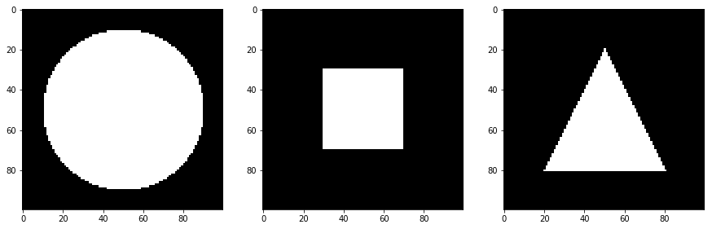

*Figure 1. Synthetic images of geometric shapes.*

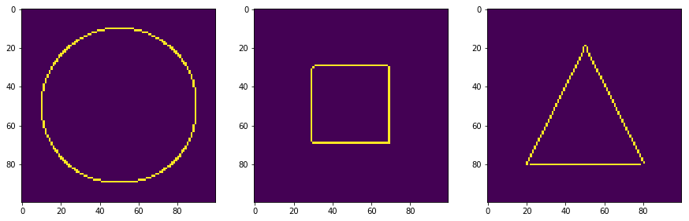

*Figure 2. Edge-detected using Canny package from Open-CV.*

Using *numpy.where,* the coordinates of the shape’s edges were listed. At start, I don’t know how these edge-detected points were arranged on my coordinates list. One way to check is to measure its polar angle with respect to the centroid point. To employ this, I used *numpy.arctan2.* Shown in Fig. 3 is the calculated polar angle vs their index on the coordinate of the

edge points of my synthetic circle. Evidently, edge-detected points adjacent to each other on the plot weren’t listed adjacent to each other on my coordinate list. I sorted the polar angles in an increasing manner as shown in Fig. 3 and saved the indices. The coordinate list was then sorted with respect to increasing polar angles using the saved indices.

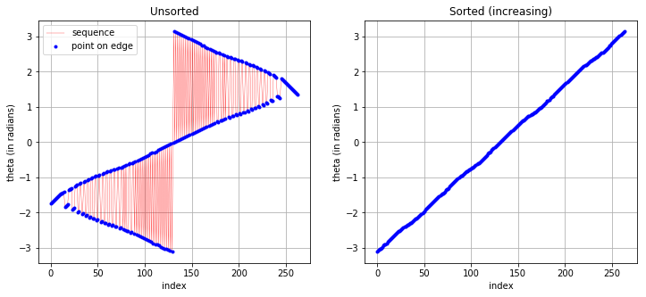

*Figure 3. (Left) The coordinate list returned by my edge detection algorithm is classified to be unsorted since the polar angle calculated isn’t arranged sequentialyl. Red lines show how adjacent indices have fluctuating polar angle counterpart. (Right)* 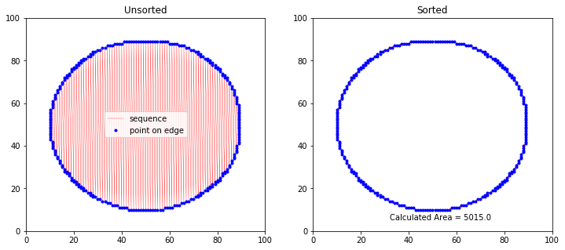

Circle

Theoretical Area = 5024

Calculated = 4965.5

Rectangle

Theoretical Area = 1600

Calculated = 1577.5

Triangle

Theoretical Area = 1800

Calculated = 1825.5

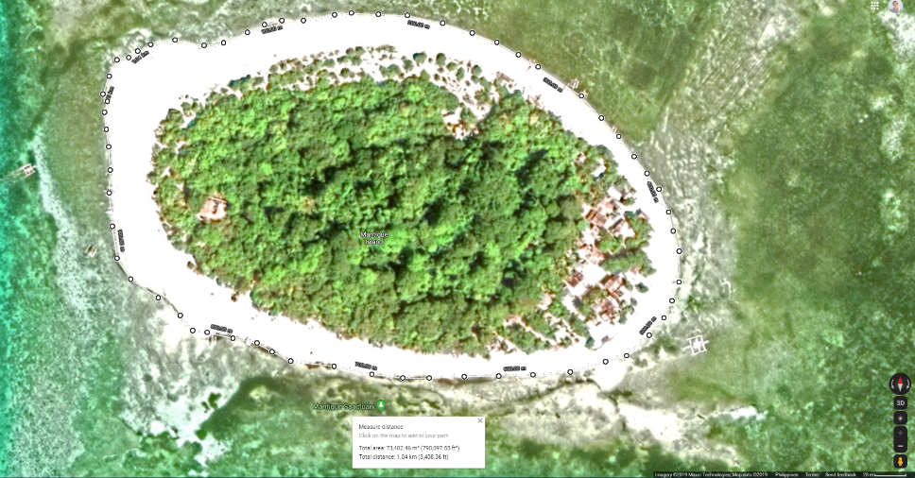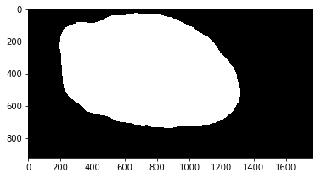

Theoretical: 73, 402.46

Calculated: 72201.83855214018

59 pixels = 20 meters.